Spectral Efficiency of MU-Massive MIMO System for Perfect and Imperfect CSI Condition

Ika Rohmatul Aini   
*Electrical Engineering Deaprtment*  
*Institut Teknologi Sepuluh Nopember*Surabaya, Indonesia  
ikaaini10@gmail.com

Puji Handayani  
*Electrical Engineering Deaprtment*  
*Institut Teknologi Sepuluh Nopember*Surabaya, Indonesia  
puji@ee.its.ac.id

*Abstract*— Multi User Massive MIMO (MU-Massive MIMO) is a form of multi-user large-scale antennas technology, in which hundreds numbers of antennas serve a significantly smaller number of users. We focus to analyze the downlink system of MU-Massive MIMO which works on Rayleigh and Uniformly Random Line of Sight (UR-LOS) channels. This system is assumed operates over a frequency-selective and uses Orthogonal Frequency Division Multiplexing (OFDM). The system performance is observed under perfect CSI and imperfect CSI conditions. Channel estimation for imperfect CSI can be obtained from uplink pilots training. ZF and MMSE linier precoding are used to overcome Multi User Interference (MUI) at receiver. From the simulation results, it can be seen that the use of a large number of array antennas can significantly increase the spectral efficiency without bound. In addition, the spectral efficiency of the downlink scheme really depends on the use of precoding techniques. ZF and MMSE work equally well in suppressing the MUI at large number of antenna elements.

Keywords— MU-Massive MIMO, Rayleigh, UR-LOS, Perfect CSI, Imperfect CSI, Spectral Efficiency, ZF, MMSE, MUI.

# Introduction

In recent years, Multiple Input Multiple Output (MIMO) technology has been developed to support the development of high-speed wireless communication systems. This technology has better performance than Single Input Single Output (SISO). This concept becomes the background for the development of Massive MIMO system. Massive MIMO system is a system that uses a very large number of antennas on the BS, the antennas can be hundreds or even more [1]. By using massive antenna elements, the spectral efficiency and energy efficiency will be significantly increased, compared to the small-scale MIMO system.

In order to serve multiple users simultaneously, the Multi User Massive MIMO (MU-Massive MIMO) system is used. Hundreds of antennas on one BS can serve tens of users at same time and frequency resources, where each user uses a single antenna. The advantages of single antenna users are that it is inexpensive, simple and uses more efficient power, but each user still get a high throughput [1].

The design and analysis of the Massive MIMO system is an interesting subject to study [2] - [5]. Some advantages of Massive MIMO system compared to conventional MIMO are, only the BS that needs to estimate the channel, the number of BS antennas is much larger than the number of users, and simple linear precoding techniques can be applied both on the uplink and downlink side [6].

In order to implement MU-Massive MIMO system which represents the real conditions, Channel State Information (CSI) on the BS or user side is required. However, channel estimation will be very complex because it is proportional to the large number of BS antennas, hence some previous research on Massive MIMO systems assumed perfect CSI conditions on both the BS and the user side [7]-[9]. In actual conditions the channel can change at any time according to the propagation environment, so estimation channel is required. This is because CSI is not only useful for obtaining high SNR on the user's side, but also in reducing interference generated by other users in a cell. The existence of a channel estimation on the BS side is known as Imperfect CSI condition, because BS only know the noisy version of the channel. We assume that the system works on TDD operation, so the uplink and downlink channels are reciprocal. BS can obtain CSI from the uplink pilots training sent by users. The number of transmitted pilots is proportional to the number of users which is much smaller than the number of BS antennas. Then BS use CSI to precode the transmitted signal in order to reducing Multi User Interference (MUI).

This paper analyses a single cell MU-Massive MIMO communication system with a downlink scheme on the Rayleigh and the Uniformly Random Line of Sight (UR-LOS) channel. This system is assumed operates over a frequency-selective and uses Orthogonal Frequency Division Multiplexing (OFDM). We investigated the performance in specific conditions. First, we assume that the BS knows the channel information (Perfect CSI). And second, BS estimates the channel at a certain coherence interval (Imperfect CSI). We use Least-Square Estimation method to estimate the channel response which is obtained from the pilots sent by users. The parameters that will be observed are Bit Error Rate (BER) and Spectral Efficiency using Zero Forcing (ZF) and Minimum Mean Square Error (MMSE) linear precoding technique .

It is shown that the use of large-scale antennas on the BS will increase spectral efficiency without bound. Hence, the use of massive number of antenna elements with a constant number of users will significantly increase the spectral efficiency. In addition, the downlink SE for the *k*-th user in a cell really depends on the precoding capability to reducing interference between users.

# System model

The downlink system of single cell Multi User Massive MIMO (MU-Massive MIMO) is shown in Fig. 1. This system is assumed work on a frequency-selective channel, so the OFDM technique is used to overcome Inter-symbol Interference (ISI). BS is equipped $M$ number of antenna and simultaneously serves $K$ number of users, each user uses a single antenna, where M is much larger than $K$.

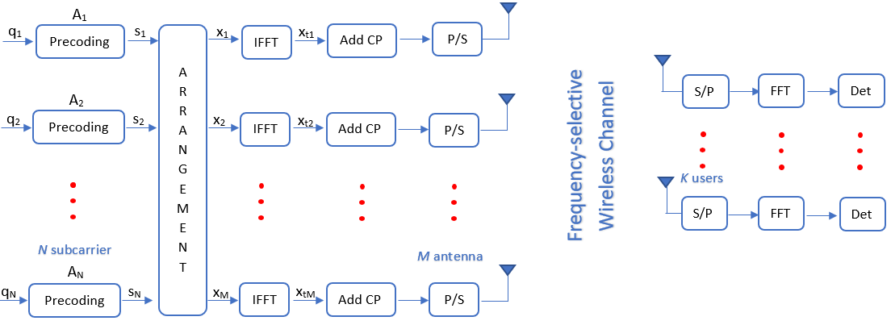

Fig. 1 System Model of MU-Massive MIMO Downlink Scheme.

Signal vector $q_{n}∈C^{M×1}$ contains QAM modulated symbols at *n-*thsubcarrier, n = 1,2,3,…*N* are total OFDM subcarriers. In fact, OFDM has subcarriers designed for data transmission ${(N}_{d})$ and unused subcarriers for guard band ${(N}_{g})$. So that there are no signal transmitted on the guard band $q_{n}∈ 0^{M×1}$.

In perfect CSI condition, we assumed that BS already knows the Channel State Information (CSI) and use it to precode the transmitted signal. We focus on analyzing the system performance under Rayleigh and UR-LOS channel conditions. The matrix $H_{l}∈C^{K×M}$ is a time domain channel response in Rayleigh channel associated with L number of channel taps, where $l=1,2,..L$. This matrix contains of complex normal random variables ${\left[H_{l}\right]}_{k,m}\sim CN\left(0,1/L\right).$ The second channel condition is Uniformly Random Line of Sight (UR-LOS) where there is no local scattering between BS and user. And all user has line of sight to the BS antennas. The time domain channel response is described in (1) [10]:

$h_{k}= \sqrt{β}{\left[1 e^{2πjdHsinθ_{k}}. . .e^{2πjdH(M-1)sinθ_{k}}\right]}^{T}$



Where $h_{k}$ is channel response associated with *k-*th user, $β$ is large-scale fading coefficient, $dH$ is array spacing and $θ_{k}$ is angular position of each user which is measured relative to array boresight. User position is random and $sin{(θ}_{k})$ is uniformly distributed at interval $\left[{-π}/2 π/2\right].$ BS uses Uniform Linear Array (ULA) antennas. Where ULA can only detect the user's position uniquely at intervals $\left[{-π}/2 π/2\right]$.

Channel matrix $\left\{H_{l}\right\}$ is assumed to be constant at certain coherence intervals. In the imperfect CSI condition, BS needs to estimate the channel response. The channel estimation can be obtained from the pilots which are transmitted by all users. At each coherence interval, each user transmits orthogonal pilot sequences at length $τ_{p}$, which are known both end of the links. The number of transmitted pilots must be greater than the number of users $(τ_{p}≥K$). Collectively, all users transmit $K×τ_{p}$ pilots. We limit the uplink transmitted signal only contains pilot signals. This pilot signal is transmitted using *N­* numbers of subcarriers. We can write the received pilot signal at ­*n­-*th subcarrier as[11]:

$y_{pn}=H_{n}x_{pn}+w_{n}$ 2

Where $x_{pn}$ is pilot signal, $H_{n}$ is channel response to be estimated and $w_{n}$ is AWGN noise. Then BS will estimate the channel from the received pilot signal using Least Square Estimation method. The estimated channel matrix for all subcarrier can be written as [11]:

$\hat{H}={({X_{p}}^{H}X_{p})}^{-1}{X_{p}}^{H}Y_{p}={X_{p}}^{-1}Y_{p}$ 3

Then the channel estimation error can be calculeted as ${\tilde{H}}_{n}={\hat{H}}_{n}-H_{n}$. From this, we can calculate the Mean Square Error (MSE) of the channel estimation using $E\left\{{\left|{\tilde{H}}_{n}\right|}^{2}\right\}$. After BS knows channel information, then BS will use this channel matrix to precode the transmited signals. There are several simple linear precoding techniques that can be applied to massive MIMO systems. In this paper we use Zero Forcing (ZF) and Minimum Mean-Square Error (MMSE) precoding technique and described as follows[8]:

$A_{ZF}={H_{n}^{H}\left(H_{n}H_{n}^{H}\right)}^{-1}$ 4

${A_{MMSE}= H}_{n}^{H}{\left(H_{n}H_{n}^{H}+\frac{K}{p_{d}}I_{K}\right)}^{-1}$ 

5

Where $A$ is precoding matiks, $p_{d}$ is downlink SNR and $I_{K}$ is $\left(K×K\right)$ identity matrix. To satisfied the total transmit power constraint on the BS, the precoding matrix should be multiplied by a scale factor as in (6)[9].

$α= \frac{1}{\sqrt{\sum_{n=0}^{N-1}{(tr{A_{n}A_{n}^{H})}/N}}}$ 6

Next, the symbols at each subcarrier are multiplied by precoding matrix. As a result is precoded vector $c_{n}{∈C}^{M×1}$ which contains the symbols that will be transmitted over *n*-th subcarrier via *M* BS antennas. In order to transmit *N* precoded vectors to *M* BS antennas, arrangement process is needed, and yields reodered vector $x_{m}$ [7] as given in (7). This means that each antenna transmits the signal from all subcarriers.

$\left[x_{1 . . . } x_{M}\right]= {\left[s_{1 . . . } s_{N}\right]}^{T}$ 7

A number of *M* vector $x_{m}$ are frequency-domain signals that will be transmitted over M antennas. Time-domain signal ${xt}_{m}$ obtained by aplying an Inverse Fast Fourier transform (IFFT) of $x_{m}$. Cyclic prefix is added to time-domain signals in order to overcome ISI that caused by transmission over frequency-selective channel. Let $X=[x_{0}, x_{1}, . . . ,x_{T-1} ]∈X^{M×T}$, $Y=[y_{0},y_{1}, . . .,y_{T-1}]∈C^{M×T}$ and $W∈CN\left(0,N_{0}\right)$ are transmitted signals, received signals and AWGN noises. All of this is in the time-domain. Then $\hat{X}=XF_{N}$**, $\hat{Y}=YF_{N}$**  and $\hat{W}=WF_{N}$ are frequency domain matrix. Where $F_{N}$ is $N×N$ DFT matrix. Then, $K×M$ frequency-domain channel matrix described as follows [9]:

${\hat{H}}_{n}= \sum_{l=0}^{L}{H_{l}exp\left(-jn\frac{2π}{N}l\right)}$ 8

After removing cyclic prefix component, frequency-domain received signal at *n-*th subcarrier is [9]:

${\hat{y}}_{n}={\hat{H}}_{n}x_{n}+w_{n}$ 9

Signal to Interfernce Noise Ratio (SINR) at *k­-*th user over *n-*th subcarrier is defined below [1]:

${SINR}_{k,n}^{A}= \frac{{\left[{\left|{\hat{H}}_{n}A_{n}\right|}^{2}\right]}_{k,k}}{\sum_{v≠k}{{\left[{\left|{\hat{H}}_{n}A_{n}\right|}^{2}\right]}_{u,v}+{ N}_{0}}}$ 0

Here ${SINR}_{k,n}^{A}$ is effective SINR for *k-*user at ­*n-*th subcarrier using precoding *A*, While $A∈\{ZF,MMSE\}$. The numerator in the equation above is desired signal for *k­*-th user. The fisrt component of the denominator is the sum of other user's power signals in the same cell or we can describe it as intracell interference, and the second component is noise variance. Then the spectral efficiency can be obtained from the following approach [10]:

$SE= \log_{2}\left(1+{SINR}_{k,n}^{A}\right)$ 1

The SE formula in (11) can be calculated numerically for different channel types and precoding schemes. The downlink SE for the k-th user in a cell really depends on the use of precoding. Therefore, choosing the most appropriate precoding technique is very important. By using precoding, each signal is sent from all antennas but with a difference amplitude and phase, so that the signal will sent directly to users.

# Numerical Results

## Single Cell Massive MIMO System

We simulated a downlink scheme single cell Massive MIMO system which operates at a frequency of 3.4 GHz. It is assumed that the interference only comes from within the cell (intracell interference) and there is no interference from other cells (intercell interference). BS uses a Uniform Linear Array (ULA) antenna with spacing between antenna elements is $λ/2$. We ssumed that all user are in the farfield area. Data transmission use OFDM modulation scheme with parameters that refer to OFDM numerology [1],[9] as shown in Table 1.

TABLE 1. OFDM Numerology

|  |  |
| --- | --- |
| **OFDM Parameters** | **Up to Frequency of 6 GHz** |
| Number of subcarriers | 512 |
| Number of used subcarriers | 300 |
| Subcarrier spacing | 15kHz |
| OFDM symbol duration | 71.4µs |
| Useful symbol duration | 66.77µs |
| Cyclic perfix duration | 4.69 µs |
| Coherence interval | 1 ms |

For Rayleigh fading frequency-selective channel conditions, the delay tap (*L* = 8) and has uniform power delay profile. Tapped delay lines can be enough to represent sparse mutilpath channel for wireless communication system. The path between users and BS are affected by the same large-scale fading $(β_{k})$ but different small-scale fading $(h_{k})$. We assumed that all users’s large-scale fading coefficient equal to unity $(β_{k}=1)$. Then independent Rayleigh fading can be referred as identical independent Rayleigh Fading (i.i.d rayleigh fading).

## Bit Error Rate (BER)

To evaluate the BER of the system, we plot the BER graph as a function of SNR with the fixed number of BS antennas and users. BS is equipped with 100 antennas *(M)* and serves 20 users *(K)* simultaneously. In order to work properly, the number of BS antennas should be at least four times the number of users $(K≤4M)$. All user posistions are random and uniformly distributed at interval $\left[{-π}/2 π/2\right]$.

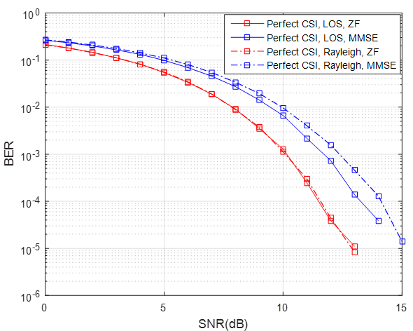

Fig. 2 BER MU-Massive MIMO at perfect CSI condition. In this example there are M = 100 antennas, K = 20 users.



Fig. 3 BER MU-Massive MIMO at perfect CSI condition. In this example there are M = 100 antennas, K = 20 users. $τ_{p}=20$

BER of system at perfect CSI condition is shown in Fig. 2 and for imperfect CSI condition is shown at Fig.3. It can be seen that ZF has better performance than MMSE both at Rayleigh or UR-LOS channels, marked with a smaller BER at the same SNR value. While at imperfect CSI condition, BS estimates the channel from the pilot signal transmitted by the user. Each user transmits 20 pilots ${(τ}_{p}=K)$. This is the minimum number of pilots that user can transmit. MSE of channel estimation is shown in Fig 4. Both Rayleigh and UR-LOS have almost the same MSE value. BER system for imperfect CSI condition is shown in Fig 3. At the same SNR value, BER system with channel estimation (Imperfect CSI) and perfect CSI are not much different. However, due to the influence of noise, the BER with the channel estimation is slightly higher than the BER in the perfect CSI condition.

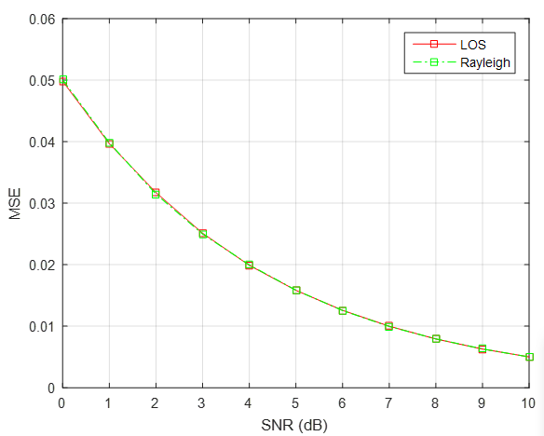

Fig. 4. Minimum Mean-Square Error (MSE) of estimated channel

## Spectral Efficiency (SE)

Spectral efficiency is a deterministic number that can be measured in bits per time unit per bandwidh or commonly known as bit / s / Hz . Where the sum SE is obtained from the sum of all users’s SE in one cell. A high SE value is the main key in designing a communication system. By increasing the number of antennas on the BS, the SE will be higher. In this simulation, SE is observed by increasing the number of BS antennas with a constant number of users. BS is equipped with a varying number of antennas, ranging from 50 to 300 and simultaneously serves 20 users. This system works on SNR of 10dB, because BER on this SNR is small, which is 10-3 as shown in Fig.1 and Fig.2. The SE graph as a function of antenna variation under perfect CSI conditions is shown in Fig.5. While the SE graph in the imperfect CSI condition is shown in Fig.6. Under the condition of Rayleigh channel, ZF precoding yields higher SE than MMSE precoding. However, in LOS conditions, MMSE precoding works as well as ZF precoding when the number of BS antennas are increasing.

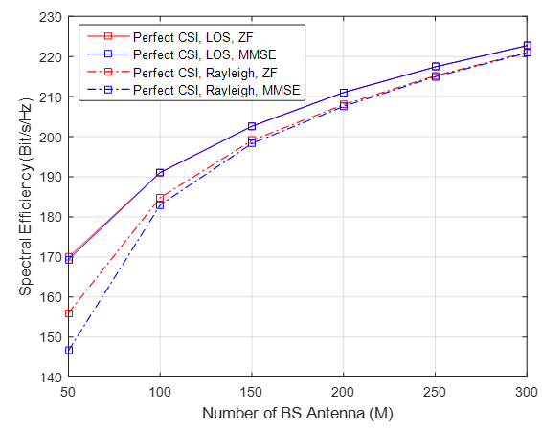

Fig. 5. Spectral Efficiency of MU-Massive MIMO at perfect CSI condition. In this example there are K = 20 users and the SNR = 10dB.

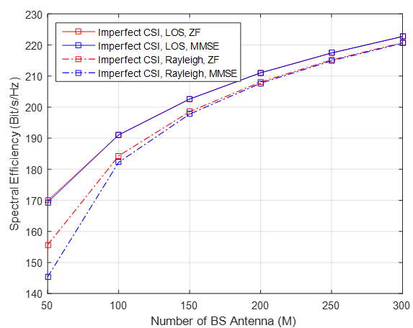

Fig. 6. Spectral Efficiency of MU-Massive MIMO at imperfect CSI condition. In this example there are K = 20 users and the SNR = 10dB.

This can be seen when the number of BS antennas is below 150, ZF still performs better than MSSE. But when the number of BS antennas is above 150, MMSE is almost same as ZF. Both in perfect CSI and imperfect CSI conditions, the total of SE will increase if the number of transmitter antennas increases.

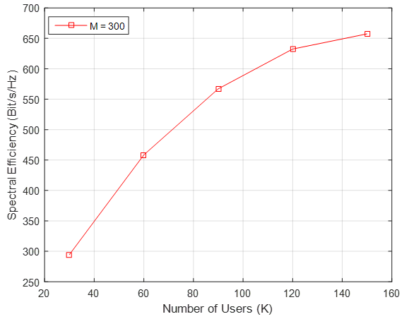

Fig. 7. Spectral Efficiency of MU-Massive. In this example there are M = 300 antennas and the SNR = 10dB.

The SE graph as a function of the number of users is shown in Fig.7. We can see that sum SE will increase as the number of users increases, on condition that the number of users is still smaller than the number of BS antennas $\left(K<M\right)$ A significant increasing of SE occurs when the number of users is in range of 20 to 80. However, when the number of users is above 80, the SE graph is starting to flatten out a bit. This is because the maximum number of users that can be served by 100 BS antennas are 80 users. As shown in Fig.8, the simulation is carried out by varying the number of users and the number of BS antennas. When BS is equipped with 100 antennas and serves less than 100 users, the SE still increases significantly. It is different when the number of BS antennas is 30 and the user served exceeds 30, then the SE has decreased. This is caused by the high interference between users and precoding can’t overcome it.



Fig. 8 Spectral Efficiency of MU-Massive with different number of BS antennas

# Conclusion

In this study, we investigated the performance of the MU-Massive MIMO system in the downlink scheme under perfect CSI and imperfect CSI condition. ZF and MMSE linear precoding techniques are implemented to reduce multiuser interference. Both ZF and MSSE are suitable precoding technique for Massive MIMO system, where MMSE works better for a large number of antennas. At the same SNR value, BER of system using ZF precoding is smaller than using MMSE. In the imperfect CSI condition, BS estimated channel information from pilots sent by users, so that BS only knows the noisy version of channel. The spectral efficiency is slightly decreased under the imperfect CSI condition due to the noise of the transmission link. Furthermore, MU-Massive MIMO system offers the possibility to increase SE significantly and serves multiple users at the same time-frequency resources.

##### References

1. H. Q. Ngo and T. L. Marzetta, “Energy and Spectral Efficiency of Very

Large Multiuser MIMO Systems,”in IEEE transaction on communication*,* vol. 61, no. 4, 2013.

1. H. Q. Ngo and T. L. Marzetta, “Energy and Spectral Efficiency of Very

Large Multiuser MIMO Systems,”in IEEE transaction on communication*,* vol. 61, no. 4, 2013.

1. T. L. Marzetta, “Noncooperative cellular wireless with unlimited numbers of BS antennas” in IEEE transaction on wireless communication vol. 9, no. 11, pp. 3590–3600, Nov. 2010.
2. Hong Yang, T.L. Marzetta, “Performance of Conjugate and Zero-Forcing Beamforming in Large-Scale Antenna Systems” in EEE Journal on Selected Areas in Communications VOL. 31, NO. 2, February 2013.
3. H.Q.Ngo, E.G.Larson, T.L.Marzetta, “Massive MU-MIMO Downlink TDD Systems with Linear Precoding and Downlink Pilots”, in Fifty first Annual Allerton Conference Allerton House, UIUC, Illinois, USA October 2 - 3, 2013.
4. A.Nasser, M. Elsabrouty, “Frequency-Selective Massive MIMO Channel Estimation and Feedback in Angle-Time Domain”, in IEEE Symposium on Computers and Communication (ISCC), 2016.
5. T. L. Marzetta and E. G. Larsson, “Fundamentals of Massive MIMO”, United Kingdom: Cambridge University Press, 2016.
6. R. Zayani, H. Syaiek, D. Roviras, “PAPR-aware Massive MIMO-OFDM Downlink”,in IEEE Acces, vol.7. Page 25474 – 25484, 2019
7. Jacobson,Sven.Durisi, Giuseppe, Studer.Christoph.” Massive MU-MIMO-OFDM Downlink with One-Bit DACs and Linear Precoding”. in IEEE Global Communications Conference. 2018
8. Sven Jacobsson, Giuseppe Durisi, Mikael Coldrey, and Christoph Studer,” Linear Precoding With Low-Resolution DACs for Massive MU-MIMO-OFDM Downlink”, in IEEE Transaction on Wireless Communication, vol. 18, no. 3, 2019.
9. Emil Björnson, Jakob Hoydis and Luca Sanguinetti , “Massive MIMO Networks: Spectral, Energy, and Hardware Efficiency”, Foundations and Trends® in Signal Processing: Vol. 11, No. 3-4, pp 154–655. DOI: 10.1561/2000000093,2017.
10. Y.S.Cho, J.Kim, W.Y.Yang, C.G.Kang,”MIMO-OFDM Wireless Communication with Matlab”, John Wiley & Sons, Ltd. 20